COMPUTER VISION
IRO2017009
MTECH - ROBOTICS

Intrinsic Parameters for camera calibration given two images

With an actual camera the focal length (i.e. the distance between the center of projection and the retinal plane), the coordinates of equation should therefore be scaled with to take this into account.
In addition the coordinates in the image do not correspond to the physical coordinates in the retinal plane. With a camera the relation between both depends on the size and shape of the pixels and of the position of the chip in the camera. With a standard photo camera it depends on the scanning process through which the images are digitized
The image coordinates are obtained through the following equations:
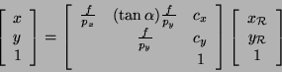

where p_{x} and p_{y} are the width and the height of the pixels,c_{x ,} c_{y} is the principal point and alpha is the skew angle.

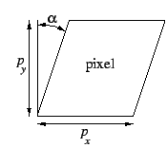

We used Matlab to get the camera calibration matrices and parameters.

Images:

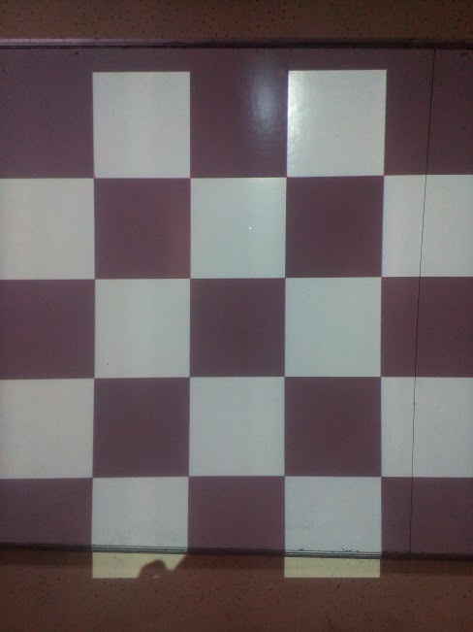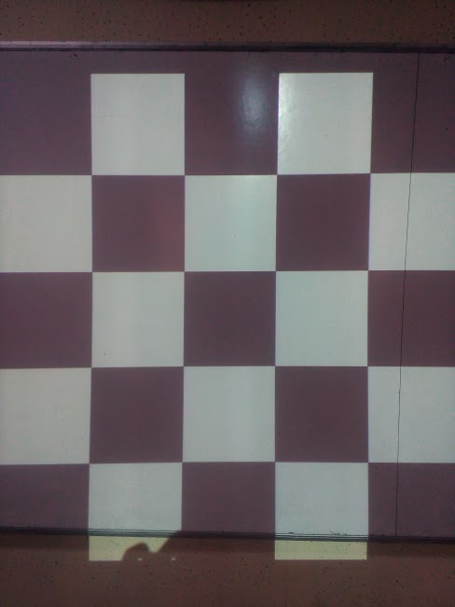

Code :

imageFileNames = {'C:\Users\Mainak Dutta\Desktop\computer vision\calibration\intrinsic1.tif',...
'C:\Users\Mainak Dutta\Desktop\computer vision\calibration\intrinsic2.tif',...

};

[imagePoints, boardSize, imagesUsed] = detectCheckerboardPoints(imageFileNames);
imageFileNames = imageFileNames(imagesUsed);

squareSize = 25;
worldPoints = generateCheckerboardPoints(boardSize, squareSize);

cameraParams = estimateCameraParameters(imagePoints, worldPoints, ...
'EstimateSkew', false, 'EstimateTangentialDistortion', false, ...
'NumRadialDistortionCoefficients', 2, 'WorldUnits', 'mm');

h1=figure; showReprojectionErrors(cameraParams, 'BarGraph');

h2=figure; showExtrinsics(cameraParams, 'CameraCentric');

originalImage = imread(imageFileNames{1});
undistortedImage = undistortImage(originalImage, cameraParams);

Output :

7.61865367e+02 0.00000000e+00 2.44000000e+02
0.00000000e+00 1.16697673e+03 3.25500000e+02
0.00000000e+00 0.00000000e+00 1.00000000e+00

Now, I am using our own images to get the intrinsic parameters.

IMAGES:

Code:

imageFileNames = {'C:\Users\Mainak Dutta\Desktop\computer vision\calibration\Image1.tif',...
'C:\Users\Mainak Dutta\Desktop\computer vision\calibration\Image2.tif',...
'C:\Users\Mainak Dutta\Desktop\computer vision\calibration\Image3.tif',...
'C:\Users\Mainak Dutta\Desktop\computer vision\calibration\Image4.tif',...
'C:\Users\Mainak Dutta\Desktop\computer vision\calibration\Image5.tif',...
};
[imagePoints, boardSize, imagesUsed] = detectCheckerboardPoints(imageFileNames);
imageFileNames = imageFileNames(imagesUsed);

squareSize = 25;
worldPoints = generateCheckerboardPoints(boardSize, squareSize);

cameraParams = estimateCameraParameters(imagePoints, worldPoints, ...
'EstimateSkew', false, 'EstimateTangentialDistortion', false, ...
'NumRadialDistortionCoefficients', 2, 'WorldUnits', 'mm');

h1=figure; showReprojectionErrors(cameraParams, 'BarGraph');

h2=figure; showExtrinsics(cameraParams, 'CameraCentric');

originalImage = imread(imageFileNames{1});
undistortedImage = undistortImage(originalImage, cameraParams);

Intrinsic Parameter:

656.166566654864 0 303.708960489219
0 658.178546282191 251.552658879499
0 0 1

As, the camera used to get the images are different in the two simulations. So the intrinsic parameters we got is different from each other.

